Economics Course Syllabus
Hare Continuation High School
Mrs. Collins, Room #6
Email: vcollins@ggusd.us

This a standards-based, five credit quarter course in which students apply critical thinking skills to investigations of Economics in the following areas:

Unit 1 – Causal Relationship between Scarcity and Need for Choices | Unit 4 –Effects of Competition in the Market Economy
Unit 2 – Incentives and Law of Supply and Demand | Unit 5- Role of Government in a Market Economy
Unit 3 – Shifts in Demand Curve, Changes in supply | Unit 6- Personal Finance
Course Description
Economics is concerned with the study of consumer behaviors and how people satisfy their wants and needs with the use of resources. This course will give students a greater understanding of economics ranging from the viewpoint of the individual consumer and business to the global economy. The course will study the big ideas in economics, such as scarcity, opportunity costs, goods and services, the law of supply and demand, government finances, and global economics.

Goals
- Understand common economic terms and concepts and economic reasoning
- Analyze the elements of America’s market economy in a global setting
- Analyze the influence of the federal government on the American economy
- Analyze the elements of the U.S. labor market in a global setting

Text: Economics Principles in Action, Pearson
These may be checked out on an individual basis. Students assume all responsibility for loss or damage.
Materials:
Students are encouraged to have a folder or binder, pen or pencil, and paper to participate in daily class work. These should be brought to class every day. Each student is responsible for the proper care of textbooks, furniture, chromebooks and the classroom in general.

Grading Policy: The grading scale is as follows:

GRADE (A-F) | LEARNING SCALE (1-5) | PERCENTAGE %
A + | (5) Exceptional | 98% or above
A / B | (4) Proficient | 80 – 97%
C | (3) Basic | 70 – 79%
D | (2) Limited | 60 – 69%
F | (1) Inadequate | 59% or below

Individual and group work will be evaluated on the quality of formative and summative assessments:

Formative (40%): (ongoing) assessments which include: warm-ups, class work, notes, individual and group work, and quizzes.

Summative (60%): (mastery) assessments, which include: standard projects, final exams, written assessments, and final presentations.

Late/Make Up Work: Students are allowed to turn in work after the due date only with an excused absence or teacher permission. Late and missing assignments can add up very quickly and can severely damage your overall grade. Students who are absent need to look at Google Classroom to see what they missed and/or the Class Extras Handouts by the front door THE DAY THEY RETURN. Teachers are not required to provide makeup work if the absence is unexcused or a truancy.

Progress Reports: In addition to the formal mid-term Progress Report (for students earning a C- or lower) and Final Grade Report, students will receive an informal meeting with the instructor expressing concerns and addressing any make up work that needs to be completed. Parents may also request weekly grade report forms from the office.

Tardy Policy: ***Subject to change. Please see Front Office for updates to Tardy Policy.
· Consequences and interventions will be assigned by the assistant principal will be 30 minutes of time owed per 3 tardies. Students will then need to “buy back” their time, but will have a menu of options to choose from.

Classroom Expectations:
- Show respect to teacher and fellow classmates
- Help keep classroom neat and clean
- Maintain a positive attitude and an open mind
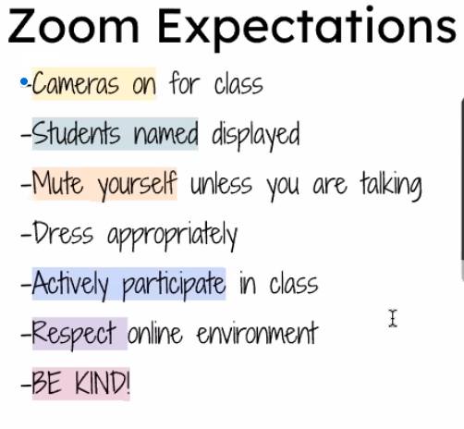

Restroom Policy:
Students are only allowed to go to the restroom 3 times during the quarter and must turn in completed bathroom pass each time upon using the restroom. Students will also give all electronic devices upon leaving the classroom and it will be returned immediately when they return. Students must attain teacher permission in order to use the restroom.

Cell Phone Policy: Cell Phones are only allowed in class with teacher permission when used for academic purposes. Improper, non-academic usage will result in an offense.
- First offense - The electronic device will be confiscated by the teacher and put in “Cell phone charging station.” Depending on severity of usage, it could be given to the assistant principal to be picked up at the end of the day.
- Second offense – The electronic device will be confiscated from the teacher and will NOT be returned. The device will be given to the assistant principal who will return the device once a parent meeting has been held.
- Third offense - Student will lose the electronic device for the remainder of the year.

***You can voluntarily use the “Cell Phone Charging Station” if you feel that you will be tempted to use your phone for non-academic purposes throughout the class period. Once the phone is at the charging station it must stay there for the remainder of the period.

Discipline Policy: Instructor will adhere to the Hare Continuation High School Discipline Policy which can be viewed in full by clicking on this link.

Academic Honesty Policy: Instructor will adhere to the Hare Continuation High School Academic Honesty Policy which can be viewed in full by clicking this link.

Internet Usage Agreement: Instructor will adhere to the Hare Continuation High School Internet Usage Agreement which can be viewed in full by clicking this link.

I look forward to sharing a wonderful 2020-2021 school year with the wonderful students and families at Hare High School. Go Huskies!

Sincerely,

Mrs. Collins

